
News Today - An English evening daily published from Chennai
www.newstodaynet.com | | Tuesday, 24 February, 2009 |

http://newstodaynet.com/newsindex.php?id=15197%20&%20section=7
Home | Nation | Tamilnadu | Chennai | World | Business | Sports | Entertainment | Special Report | Archives

Kalaimamani Awards Announced
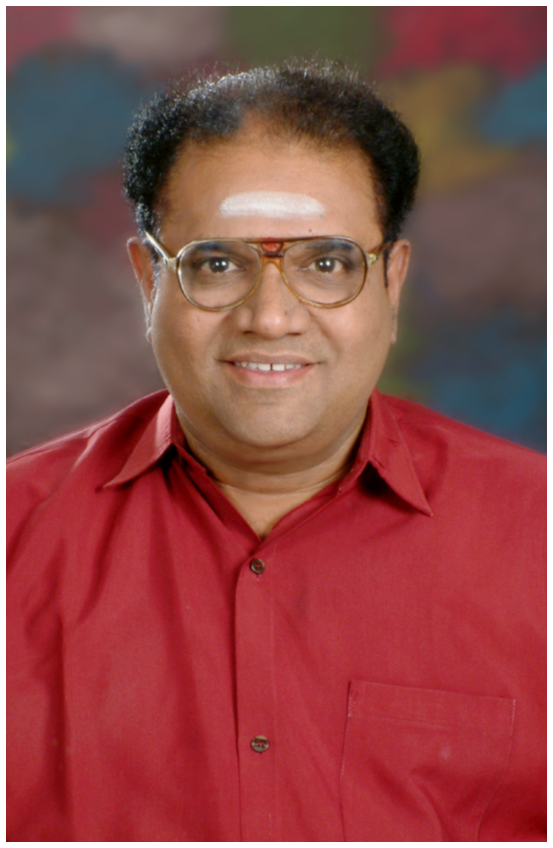

NT Bureau | Tue, 24 Feb, 2009,02:31 PM

The State government today announced Kalaimamani awards to 70 personalities from various walks of the society. The prominent awardees include film personalities Asin, Nayantara, Meera Jasmine and veteran actress B Saroja Devi.
Some of the notable awardees, according to an official press release issued here include, Tamil scholar Avvai Natarajan, Carnatic musicians Maharajapuram Sreenivasan, V S Kumar, Embar Kannan, Vazhuvoor Ravi, Veeramani Raju, noted drummer Shivamani, orator Suki Sivam, bharathanatyam dancers Aishwarya Rajnikanth Dhanush, Vasantha Mukunth, Swetha Gopalan, film producer Abhirami Ramanathan, film personalities Cheran, Sundar C, Bharath, Asin, nayantara, Meera Jasmine, Pasupathy, Shobana, Vaiyapuri, Harris Jeyaraj, R D Rajasekhar, small screen artistes Sundar K Vijayan, Thiruselvan, Abhishek.

